

**Instituto Politécnico Nacional**

**ESCOM “Escuela Superior de Cómputo”**

INGENIERÍA EN SISTEMAS COMPUTACIONALES

*Análisis Fundamental de Circuitos*

*Práctica 1*

Profesor: Figueroa Del Prado Felipe De Jesús

ALUMNO

Rojas Alvarado Luis Enrique

Grupo:

**1CM6**

Index

**Objective1**

**Material**1

**Equipment**1

**Theorist introduction1**

How to measure circuit voltage2

How to measure circuit current2

How to measure the series circuit electrical resistance2

Protoboard or breadboard3

Breadboard structure3

**Experimental progress**4

Ohmmeter use4

Voltmeter use5

Ammeter use6

**Calculations**6

Voltage calculations6

Current calculations7

**Circuit simulations**8

Series circuit simulations8

Parallel circuit simulations14

**Comparative of calculated, measured and simulated values**20

Comparative of voltaje values20

Comparative of current values25

**Questionnaire**29

**Inferences**30

**Bibliography**30

# Objective

The practice purpose is understand the proper handling of the measuring instruments so, at the end of it we had have learned how to properly use the ohmmeter, voltmeter and ammeter. We also understood the ways to measure resistor circuits in series or parallel.

# Material

* Protoboard
* 1k ohm resistor
* 560 ohm resistor
* 680 ohm resistor
* 330 ohm resistor
* Connection wires

# Equipment

* Digital multimeter
* Variable voltage source
* 4 banana-cayman points
* 2 cayman-cayman points

# Theorist introduction

The first figure shows two common meter forms, one of them (the analogic one) has an indicator needle that moves on a calibrated scale whose angular deflection depends on the magnitude of the variable it measures. The other one is a digital meter which shows a digit serie on the screen, indicating the magnitude of the variable it measures. The second figure shows the voltmeter and ammeter symbols that are used in electrical circuit diagrams.

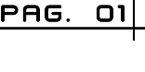

1. Analogic meter
2. Digital Meter

## How to measure circuit voltage

To measure the voltage between 2 points, the voltmeter has to be connected in parallel with the electronic device from which you want to know the voltage.

## How to measure circuit current

To measure the current in a circuit branch, that branch has to be opened and insert the ammeter in such a way the meter must be connected with the element in series of which you want to know its current.

## How to measure the series circuit electrical resistance

Its value is measured in ohms and is designated with the Greek letter omega capital

There are three fundamental characteristics:

* Resistance value
* Potency
* Tolerance

The resistance value and the tolerance are indicated with bands of color, the last band indicates the tolerance, that is, how much the real value can differ with the one indicated in the body.

In the 4-band coding, if the tolerance band is missing, it means that the tolerance is +/- 20%.

|  |  |  |  |  |
| --- | --- | --- | --- | --- |
| COLOR | BAND 1 | BAND 2 | MULTIPLIER | TOLERANCE |
| BLACK | 0 | 0 | x1 |  |
| BROWN | 1 | 1 | x10 | +/- 1% |
| RED | 2 | 2 | x100 | +/- 2% |
| ORANGE | 3 | 3 | x1000 |  |
| YELLOW | 4 | 4 | x10000 |  |
| GREEN | 5 | 5 | x100000 |  |
| BLUE | 6 | 6 | x1000000 |  |
| PURPLE | 7 | 7 |  |  |
| GREY | 8 | 8 |  |  |
| WHITE | 9 | 9 |  |  |
| GOLD |  |  | x0.1 | +/- 5% |
| SILVER |  |  | x0.01 | +/- 10% |
| WITHOUT BAND | | | | +/- 20% |

The first band indicates the first digit of the resistance value. The second band, gives the second digit.

The third band is the multiplier, that is, a factor with which we must multiply the number of the first two bands. In the table you can see all the colors, the bands and the corresponding values

## Protoboard or breadboard

It is a kind of board with holes, in which you can insert electronic components and cables to assemble circuits. As the name implies, this tablet is used to experiment with electronic circuits, which ensures the proper functioning of it.

### Breadboard structure

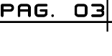basically a breadboard is divided by 3 regions:

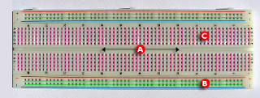

1. Center channel: It is located in the middle of the breadboard, it’s used to place the integrated circuits
2. Buses: Buses are located at both ends of the breadboard, are represented by red lines (positive or voltage buses) and blue (negative or ground buses) and drive according to these, there is no physical connection between them. The power source usually connects here.
3. Tracks: The tracks are located in the central part of the breadboard, they are represented and lead according to the pink lines.

# Experimental progress

## Ohmmeter use

The first thing we did was to connect the resistors independently and without energizing, then measure them with the ohmmeter and corroborate their exact value in ohms, the respective values ​​marked by the ohmmeter were captured in a comparative table with their commercial value and their shown value. This is where we learned to use the ohmmeter.

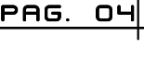**Table1. Measurement of resistance values**

|  |  |  |  |
| --- | --- | --- | --- |
| Resistance | Measurement with digital ohmmeter | Values with colors code | Simulated values |
| R1 | 328 Ω | 330 Ω | 330 Ω |
| R2 | 991 Ω | 1000 Ω | 1000 Ω |
| R3 | 666 Ω | 680 Ω | 680 Ω |
| R4 | 550 Ω | 560 Ω | 560 Ω |

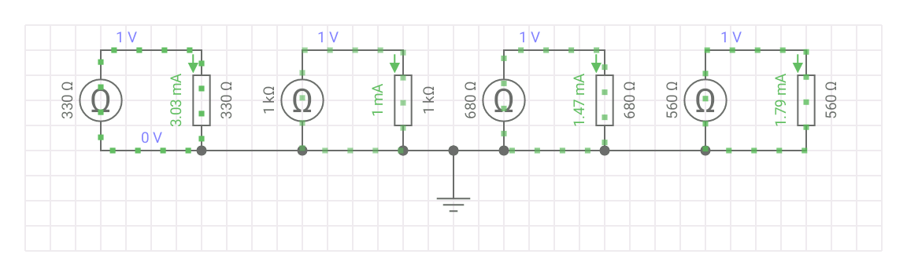

## Voltmeter use

For Voltmeter use 2 resistors were used (1kΩ and 330Ω respectively) which were connected to the protoboard in series, energizing from 1V to 12V both resistances. Having our circuit closed, the voltmeter tips were taken and placed on each end of the resistors, so the voltmeter showed the value in volts that passed through each of the resistances.

**Table 2. Voltage measurement**

|  |  |  |  |  |  |  |
| --- | --- | --- | --- | --- | --- | --- |
| Voltage source | Digital multimeter | | | Calculated values | | |
| R1 and R2 voltage | R1 Voltage | R2 Voltage | R1 and R2 voltage | R1 Voltage | R2 Voltage |
| 1V | 0.98V | 0.73V | 0.21V | 1V | 0.75V | 0.247V |
| 2V | 2V | 1.51V | 0.5V | 2V | 1.5V | 0.495V |
| 3V | 3V | 2.25V | 0.74V | 3V | 2.25V | 0.742V |
| 4V | 3.9V | 2.99V | 0.98V | 4V | 3V | 0.99V |
| 5V | 4.8V | 3.65V | 1.25V | 5V | 3.75V | 1.273V |
| 6V | 5.8V | 4.41V | 1.45V | 6V | 4.51V | 1.488V |
| 7V | 6.9V | 5.2V | 1.72V | 7V | 5.26V | 1.736V |
| 8V | 7.99V | 5.98V | 1.98V | 8V | 6.01V | 1.948V |
| 9V | 8.97V | 6.82V | 2.26V | 9V | 6.76V | 2.233V |
| 10V | 9.93V | 7.45V | 2.47V | 10V | 7.51V | 2.481V |
| 11V | 11V | 8.26V | 2.73V | 11V | 8.27V | 2.729V |
| 12V | 11.96V | 8.97V | 2.98V | 12V | 9.02V | 2.977V |

## Ammeter use

For Ammeter use the circuit consists of 2 resistors connected in parallel (560Ω and 680Ω) which were energized from 1V to 12V and to measure the current that passed through each component was required to do a bridge from the source to the resistance. This means that we used the tips of the Ammeter as one more wire without altering the circuit structure and without loss of values. All these values, like the previous ones, were captured in a table.

**Table 3. Current measurement**

|  |  |  |  |
| --- | --- | --- | --- |
| Voltage source | Digital multimeter | | |
| Current through R1 and R2 | Current through R1 | Current through R2 |
| 1V | 2.55 mA | 1.52 mA | 1.33 mA |
| 2V | 6.6 mA | 3.04 mA | 2.54 mA |
| 3V | 9.68 mA | 5.47 mA | 3.84 mA |
| 4V | 12.83 mA | 7.18 mA | 5.89 mA |
| 5V | 16.14 mA | 9.05 mA | 7.39 mA |
| 6V | 19.51 mA | 10.8 mA | 8.90 mA |
| 7V | 22.71 mA | 12.65 mA | 10.36 mA |
| 8V | 25.9 mA | 14.55 mA | 11.90 mA |
| 9V | 29.3 mA | 16.38 mA | 13.43 mA |
| 10V | 32.6 mA | 18.15 mA | 14.93 mA |
| 11V | 35.9 mA | 20.06 mA | 16.38 mA |
| 12V | 39.27 mA | 21.96 mA | 17.99 mA |

# Calculations

## Voltage calculations

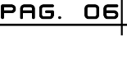To do the voltage and current calculations we used Ohm's Law:

$$V=IR$$

To calculate the voltage of the resistors, it is necessary to first know the current through them, as it is a series circuit the current passing through a resistance is the same for all.

In this case all the resistances are added to obtain the equivalent and then the Ohm's law is used

The resistances only add up because they are connected in series:

$$R1+R2=R_{eq}$$

For this practice the equivalent resistance is:

$$R_{eq}=1000Ω+330Ω=1330Ω$$

And to calculate the current through the resistors the intensity of the formula is cleared:

$$I=\frac{V}{R_{eq}}$$

For this practice the current is:

$$I=\frac{V}{1330Ω}$$

The voltaje source is variable

Once obtained the current for all resistors just need to use Ohm's law to know the voltage that passes through each of them

## Current calculations

# To calculate the current that passes through the resistors in the parallel circuit, Ohm's law is used again. In this case the intensity is cleared in the equation, since the voltage and resistance values are already given:

$$I=\frac{V}{R_{eq}}$$

# Circuit simulations

## Series circuit simulations

The simulations are ordered by voltage, from 1 volt up to 12 volts

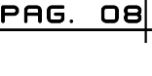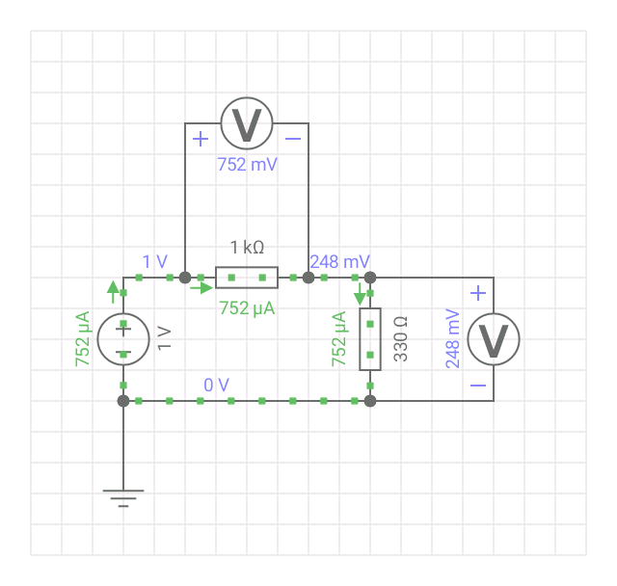

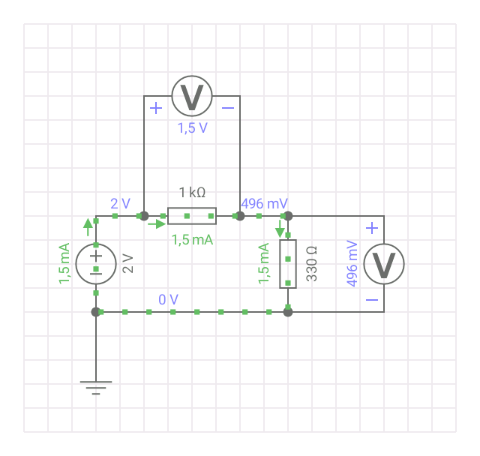

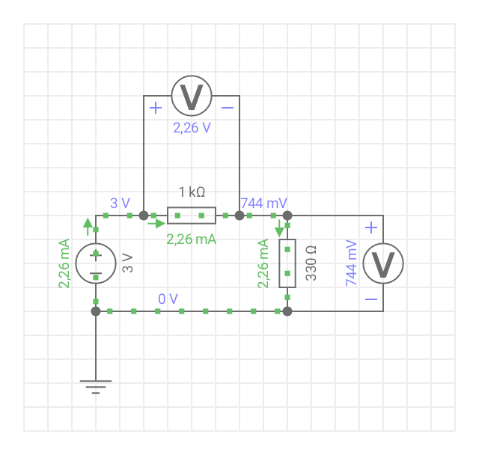

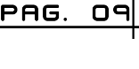

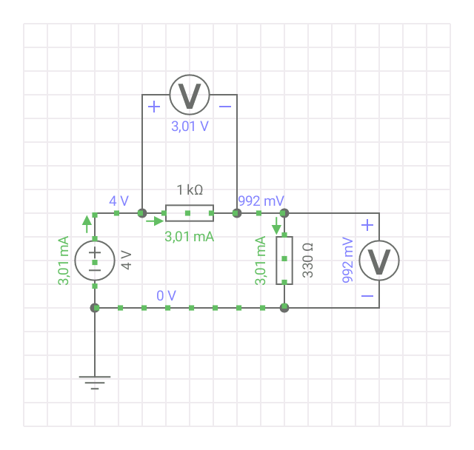

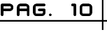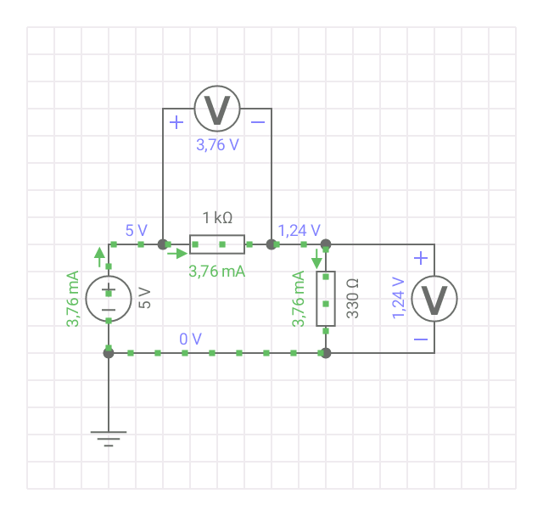

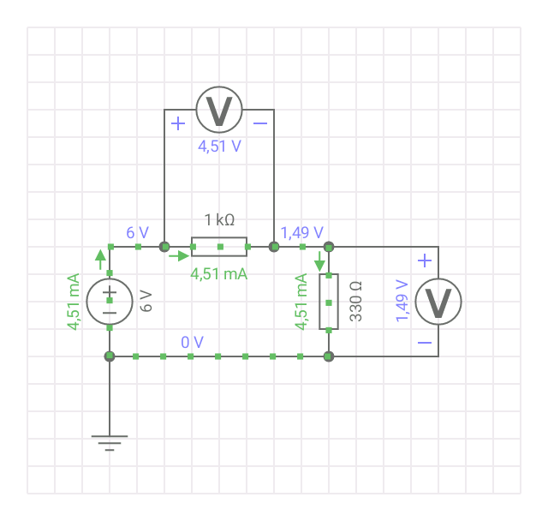

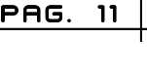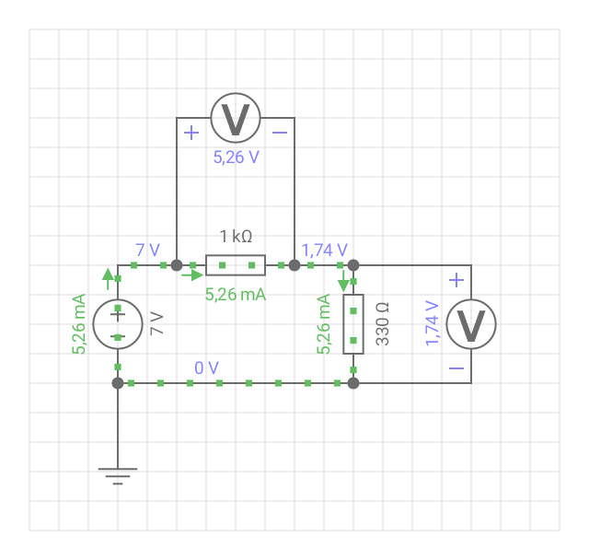

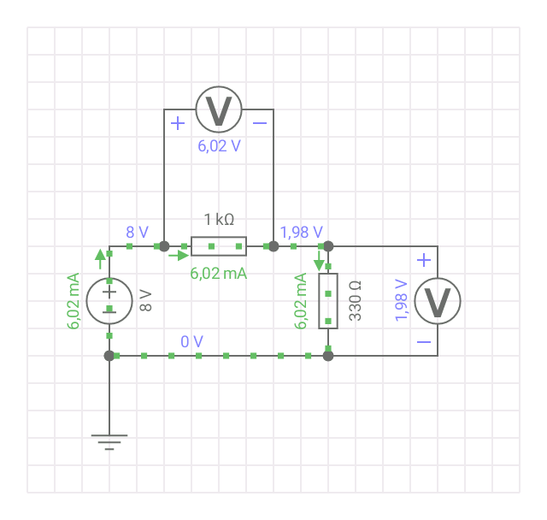

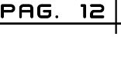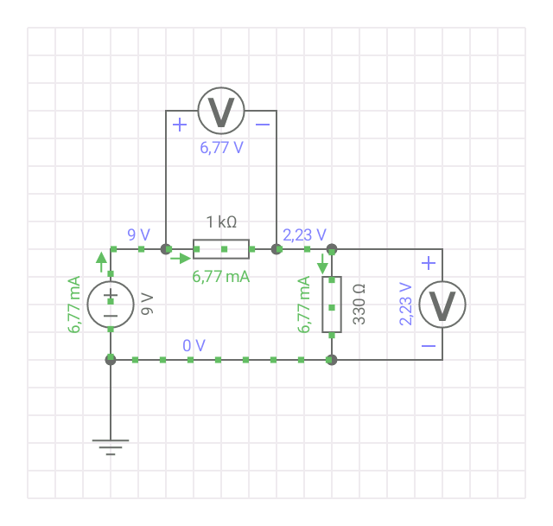

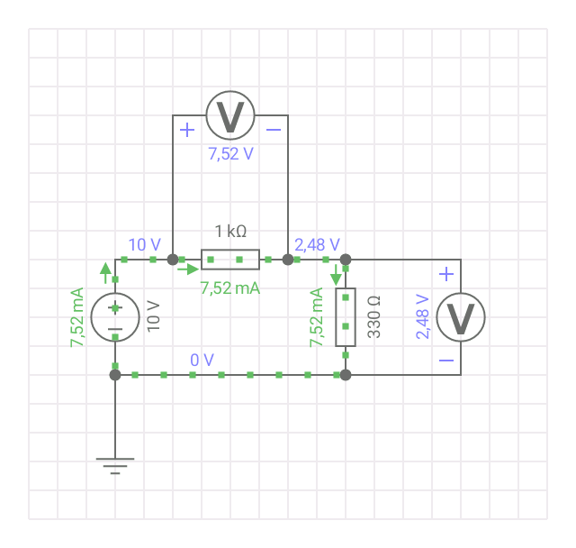

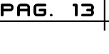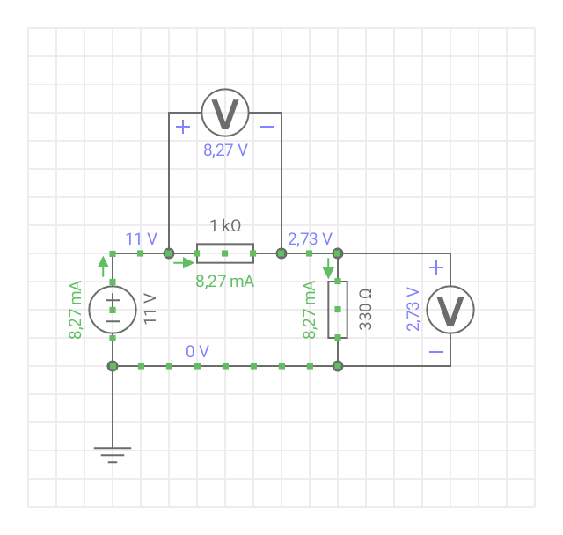

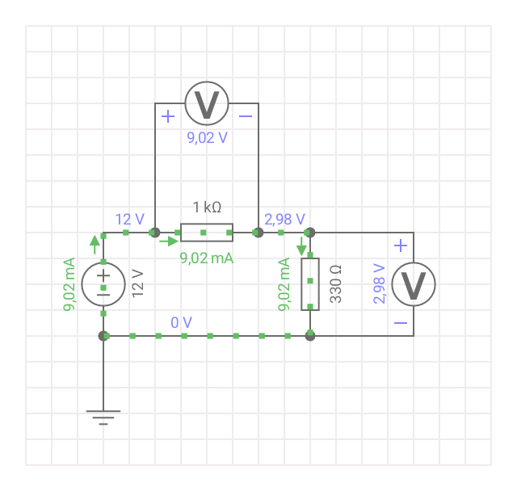

## Parallel circuit simulations

The simulations are ordered by voltage, from 1 volt up to 12 volts

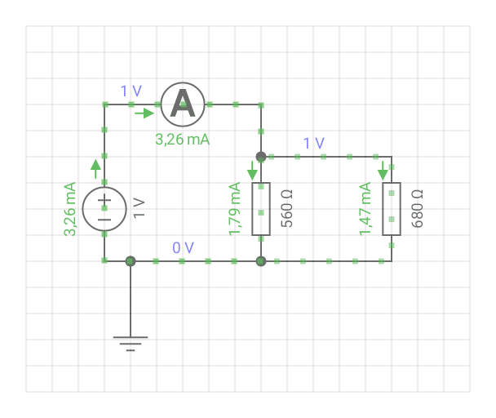

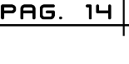

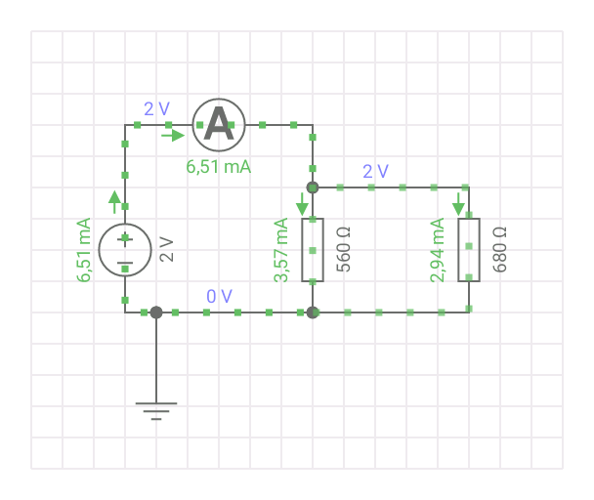

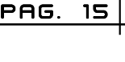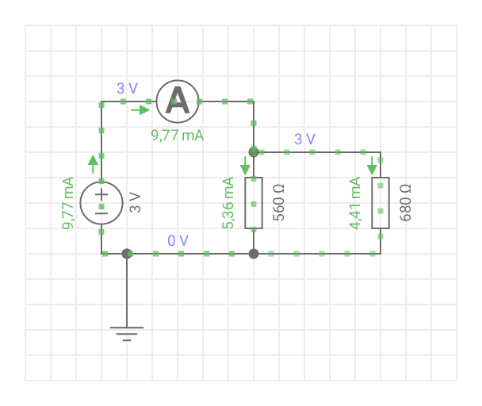

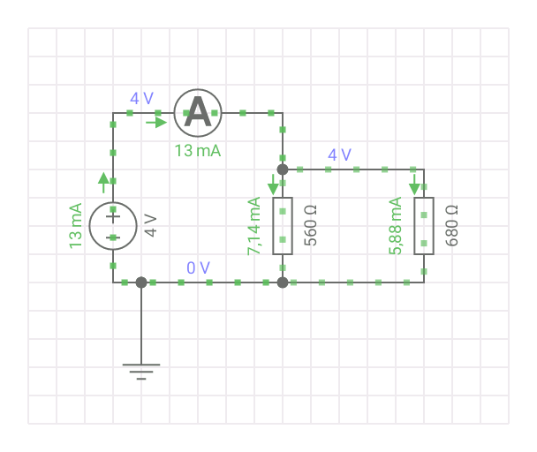

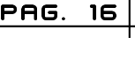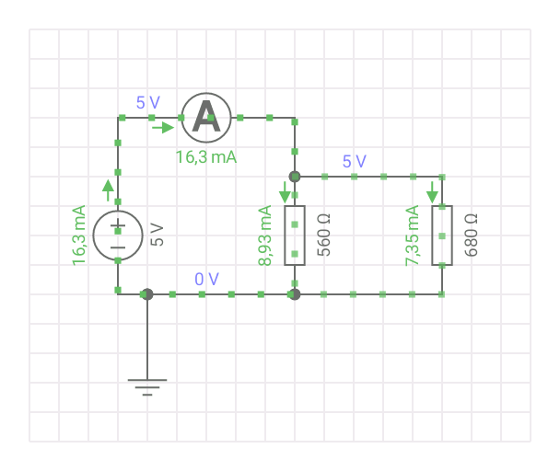

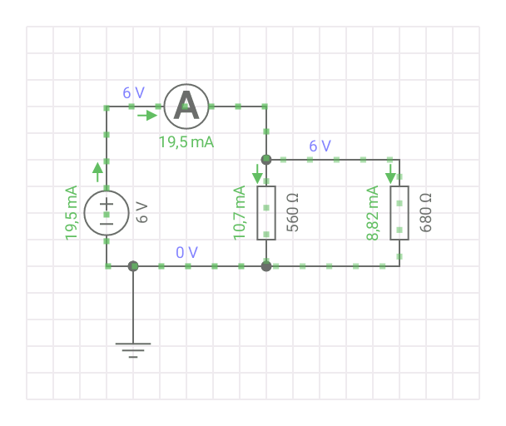

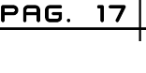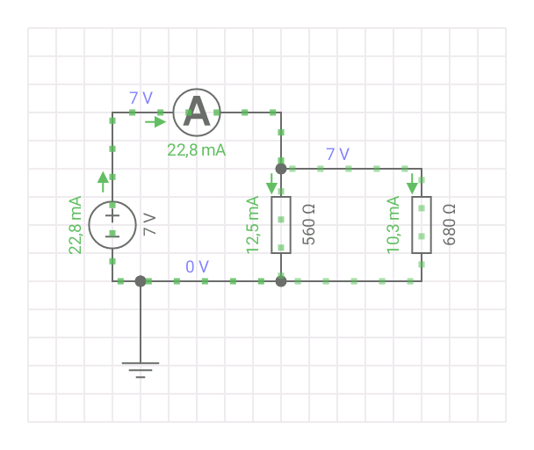

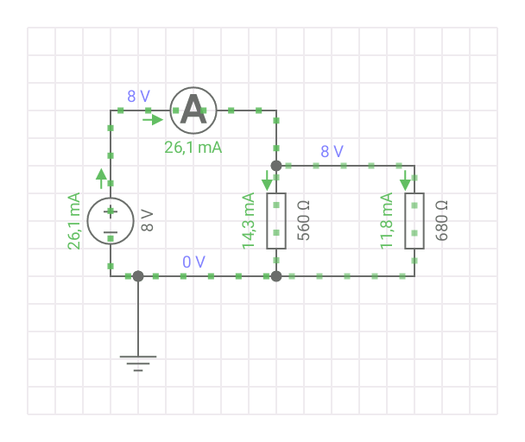

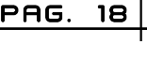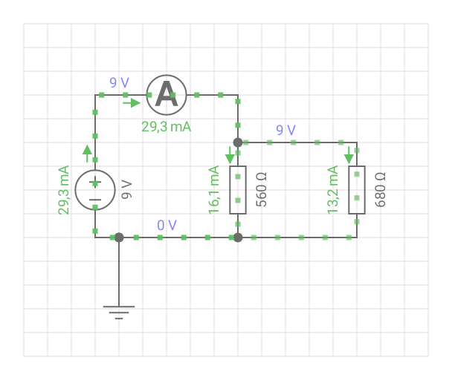

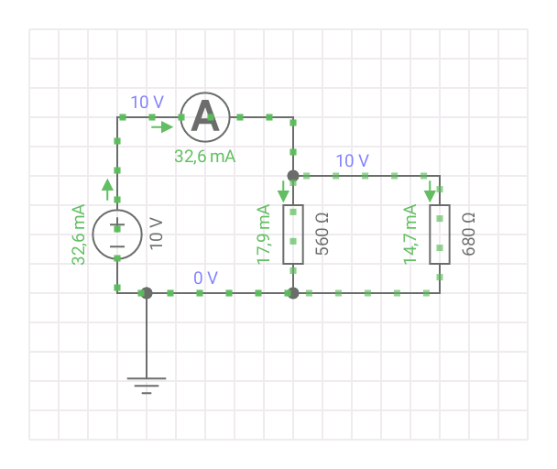

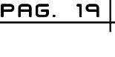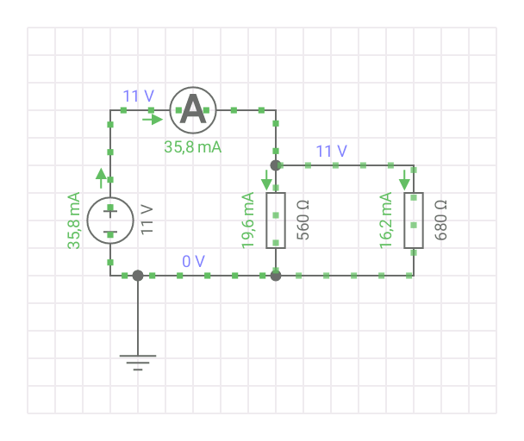

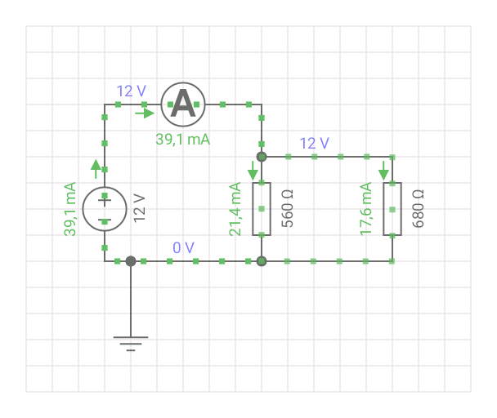

# Comparative of calculated, measured and simulated values

## Comparative of voltage values

|  |  |  |  |
| --- | --- | --- | --- |
| Voltage source | R1 and R2 values | | |
| Multimeter | Calculated | Simulated |
| 1V | 0.98V | 1V | 1V |
| 2V | 2V | 2V | 2V |
| 3V | 3V | 3V | 3V |
| 4V | 3.9V | 4V | 4V |
| 5V | 4.8V | 5V | 5V |
| 6V | 5.8V | 6V | 6V |
| 7V | 6.9V | 7V | 7V |
| 8V | 7.99V | 8V | 8V |
| 9V | 8.97V | 9V | 9V |
| 10V | 9.93V | 10V | 10V |
| 11V | 11V | 11V | 11V |
| 12V | 12V | 12V | 12V |



|  |  |  |  |
| --- | --- | --- | --- |
| Voltage source | R1 Values | | |
| Multimeter | Calculated | Simulated |
| 1V | 0.73V | 0.75V | 0.752V |
| 2V | 1.51V | 1.5V | 1.5V |
| 3V | 2.25V | 2.25V | 2.26V |
| 4V | 2.99V | 3V | 3.01V |
| 5V | 3.65V | 3.75V | 3.76V |
| 6V | 4.41V | 4.51V | 4.51V |
| 7V | 5.2V | 5.26V | 5.26V |
| 8V | 5.98V | 6.01V | 6.02V |
| 9V | 6.82V | 6.76V | 6.77V |
| 10V | 7.45V | 7.51V | 7.52V |
| 11V | 8.26V | 8.27V | 8.27V |
| 12V | 8.97V | 9.02V | 9.02V |

|  |  |  |  |
| --- | --- | --- | --- |
| Voltage source | R2 Values | | |
| Multimeter | Calculated | Simulated |
| 1V | 0.21V | 0.247V | 0.248V |
| 2V | 0.5V | 0.495V | 0.496V |
| 3V | 0.74V | 0.742V | 0.744V |
| 4V | 0.98V | 0.99V | 0.992V |
| 5V | 1.25V | 1.273V | 1.24V |
| 6V | 1.45V | 1.488V | 1.49V |
| 7V | 1.72V | 1.736V | 1.74V |
| 8V | 1.98V | 1.948V | 1.98V |
| 9V | 2.26V | 2.233V | 2.23V |
| 10V | 2.47V | 2.481V | 2.48V |
| 11V | 2.73V | 2.729V | 2.73V |
| 12V | 2.98V | 2.977V | 2.98V |

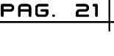

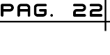

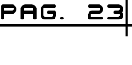

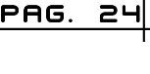

## Comparative of current values

|  |  |  |  |
| --- | --- | --- | --- |
| Voltage source | R1 and R2 Values | | |
| Multimeter | Calculated | SImulated |
| 1V | 2.55 mA | 3.25mA | 3.26mA |
| 2V | 6.6 mA | 6.51mA | 6.51mA |
| 3V | 9.68 mA | 9.76mA | 9.77mA |
| 4V | 12.83 mA | 13.02mA | 13mA |
| 5V | 16.14 mA | 16.28mA | 16.3mA |
| 6V | 19.51 mA | 19.53mA | 19.5mA |
| 7V | 22.71 mA | 22.79mA | 22.8mA |
| 8V | 25.9 mA | 26.05mA | 26.1mA |
| 9V | 29.3 mA | 29.3mA | 29.3mA |
| 10V | 32.6 mA | 32.56mA | 32.6mA |
| 11V | 35.9 mA | 35.81mA | 35.8mA |
| 12V | 39.27 mA | 39.07mA | 39.1mA |

|  |  |  |  |
| --- | --- | --- | --- |
| Voltage source | R1 Values | | |
| Multimeter | Calculated | SImulated |
| 1V | 1.52 mA | 1.78mA | 1.79mA |
| 2V | 3.04 mA | 3.57mA | 3.57mA |
| 3V | 5.47 mA | 5.35mA | 5.36mA |
| 4V | 7.18 mA | 7.14mA | 7.14mA |
| 5V | 9.05 mA | 8.92mA | 8.93mA |
| 6V | 10.8 mA | 10.71mA | 10.7mA |
| 7V | 12.65 mA | 12.5mA | 12.5mA |
| 8V | 14.55 mA | 14.28mA | 14.3mA |
| 9V | 16.38 mA | 16.07mA | 16.1mA |
| 10V | 18.15 mA | 17.85mA | 17.9mA |
| 11V | 20.06 mA | 19.64mA | 19.6mA |
| 12V | 21.96 mA | 21.42mA | 21.4mA |



|  |  |  |  |
| --- | --- | --- | --- |
| Voltage source | R2 Values | | |
| Multimeter | Calculated | SImulated |
| 1V | 1.33 mA | 1.47mA | 1.47mA |
| 2V | 2.54 mA | 2.94mA | 2.94mA |
| 3V | 3.84 mA | 4.41mA | 4.41mA |
| 4V | 5.89 mA | 5.88mA | 5.88mA |
| 5V | 7.39 mA | 7.35mA | 7.35mA |
| 6V | 8.90 mA | 8.82mA | 8.82mA |
| 7V | 10.36 mA | 10.29mA | 10.3mA |
| 8V | 11.90 mA | 11.76mA | 11.8mA |
| 9V | 13.43 mA | 13.23mA | 13.2mA |
| 10V | 14.93 mA | 14.7mA | 14.7mA |
| 11V | 16.38 mA | 16.17mA | 16.2mA |
| 12V | 17.99 mA | 17.64mA | 17.6mA |

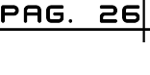

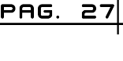

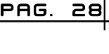

# Questionnaire

1. What is the characteristic of a series circuit?
   1. The current that passes through it is the same for all components, the voltage decreases as it passes through the components and the total resistance is the sum of all the resistances.
2. What is the characteristic of a parallel circuit?
   1. The current that passes through it is the sum of the currents of each mesh, the voltage is the same throughout the circuit and the total resistance is the inverse of the inverse sums of the resistors.
3. Which is the principal difference between an analog meter and a digital one?
   1. In the case of analog meters, it is easy to see the qualitative variations of the parameters to quickly see if the value increases or decreases. But the readings have serious errors when the instrument has several scales.
   2. In the case of digital meters, they can eliminate the possibility of errors due to confusion of scales. But non-linear scales are difficult to introduce.
4. Why does not an ammeter have to be connected in parallel?
   1. Because they do not mark anything and if we put an ammeter in parallel, it can get damaged, because, since its resistance is very small, the intensity of current in it will be higher.
5. Why should the circuit be de-energized when measuring the resistance of an electrical circuit?
   1. 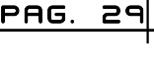When measuring the resistance of a system, the relationship between the applied voltage and the current flowing is taken into account, if there are loaded elements they can distort the measurement.

# Inferences

## Inferences of Luis Rojas

To measure the currents and voltages within the circuits in series and parallel the laws of both Ohm and Kirchhoff must be applied but in practice the meter must be connected in series or in parallel according to the case and according to the resistance that we want measure and that sometimes confuses me a little personally.

## Inferences of Aldo Rodríguez

In this practice the main objective is to learn how to use the multimeter, several measurements were made to series and parallel circuits with different resistances. After performing the practice, I am still a little confused about measuring values with the ammeter in circuits connected in parallel.

## Inferences of Ruben Quintana

In this practice we learned to use the multimeter in an appropriate way to measure values of resistances, voltages and currents. The difficult part that confused many students was measuring current values in parallel.

# Bibliography

1. <https://prezi.com/xkgrqsfp1sui/como-se-mide-voltaje-intensidad-y-resistencia-en-un-circuito-serie/>
2. <https://www.inventable.eu/2015/06/04/como-se-leen-los-colores-de-las-resistencias/>
3. <http://www.circuitoselectronicos.org/2007/10/el-protoboard-tableta-de-experimentacin.html>

